**Steps to use Password Upload Utility  
  
Login to PVWA BOX 10.32.24.132**

* Login to PVWA Server using our Admin ID. Go to C:\Program Files (x86)\CyberArk\Password Upload Utility and copy the password.csv file and paste it to your EH Desktop

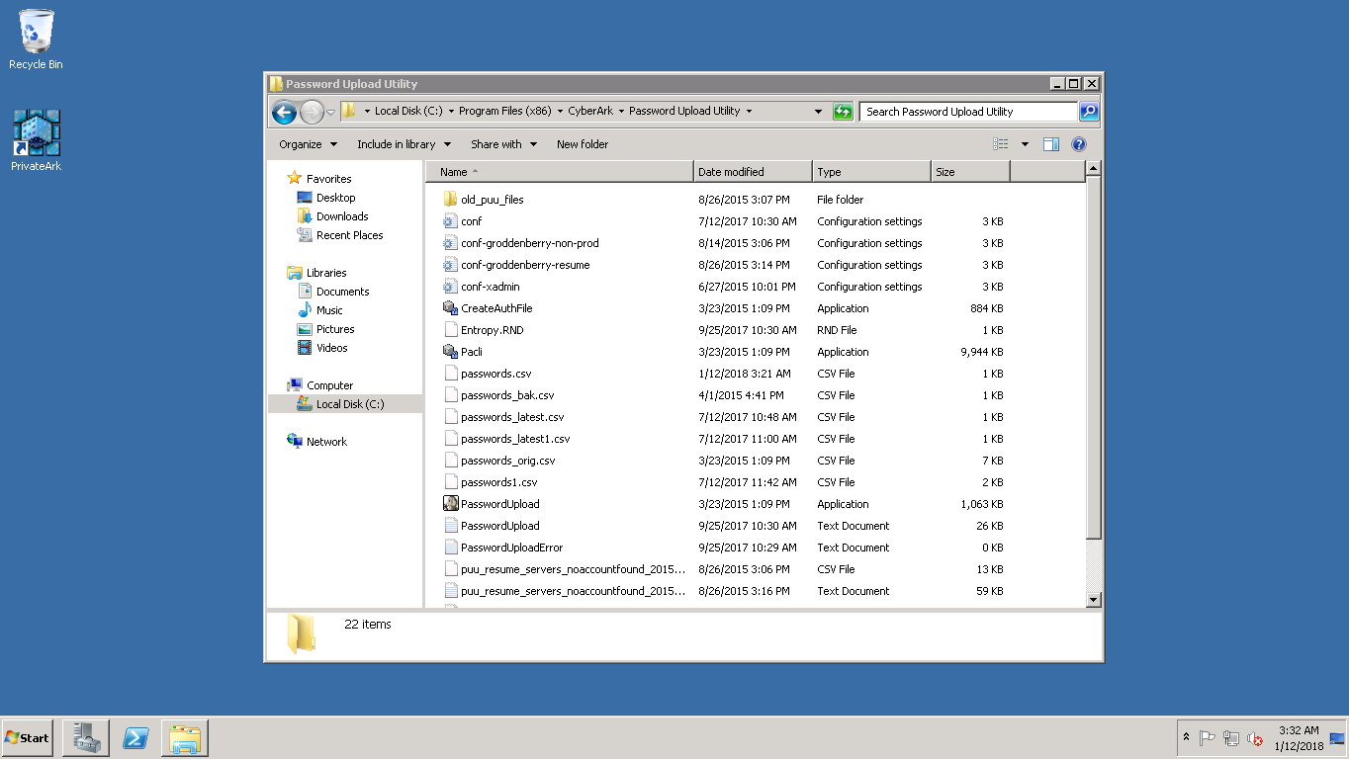

* Open the password.csv file and fill all the required attributes. For password name, use the name attribute in the PVWA for such type of accounts on boarded. For policy ID, login to PVWA and go to Administration>>Platform Management. Choose the platform name and double click and go to general settings and use the value given against ‘ID’ attribute. Address here would be ‘hostname’.systems.emblemhealth.com

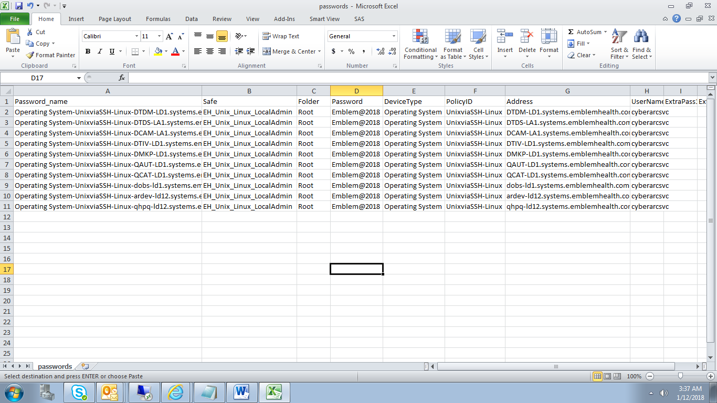

* Save the document and press Yes on the given dialog box.

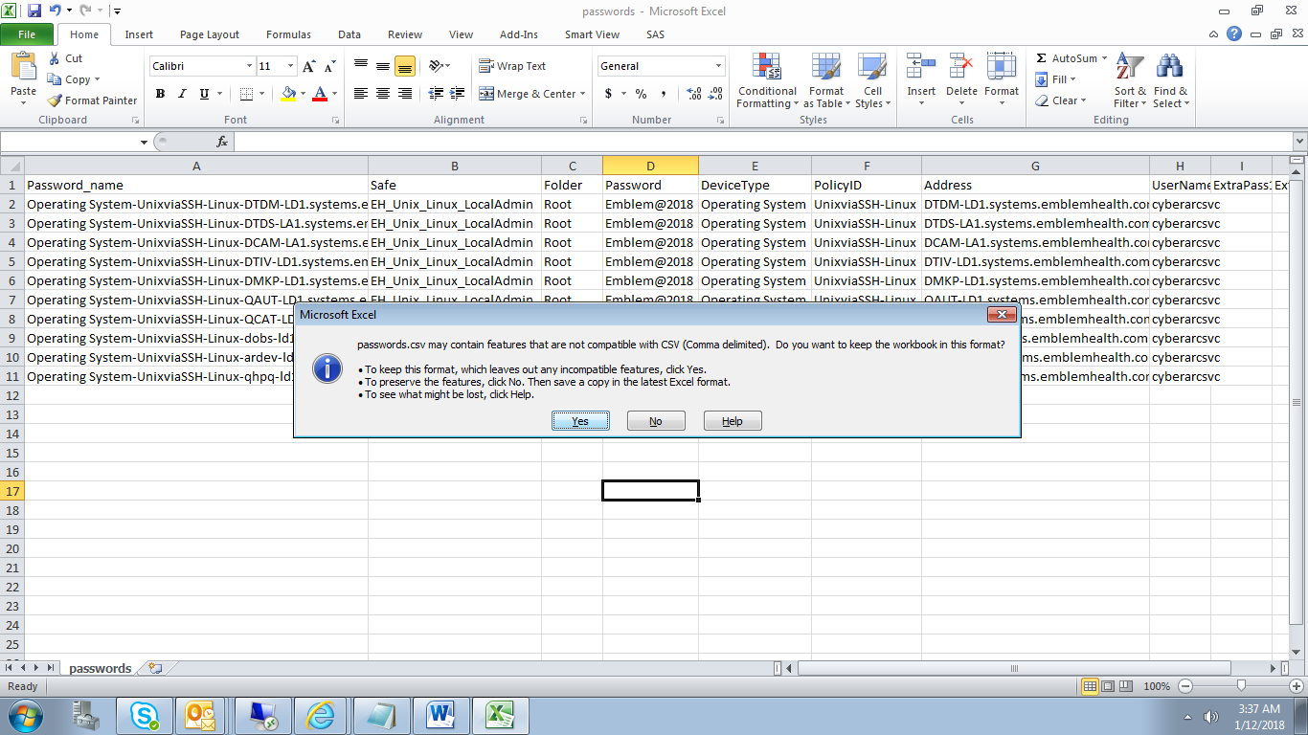

* Close the Document and click Don’t Save in the dialog box that comes next.

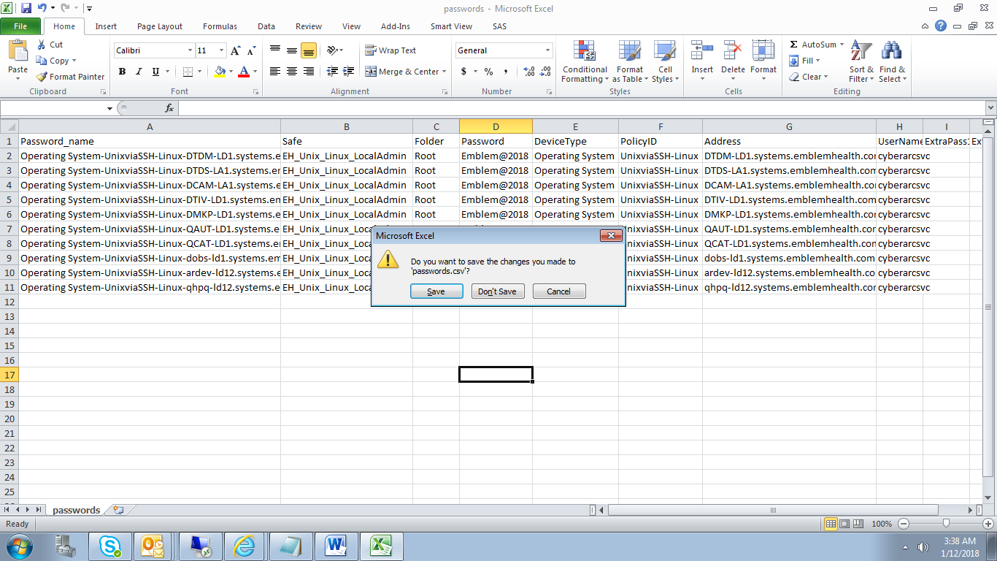

* Open the same file in notepad now.

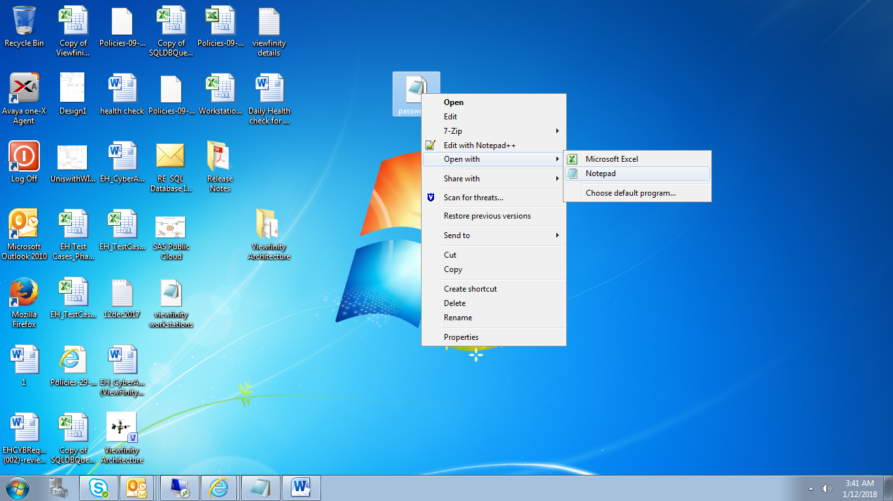

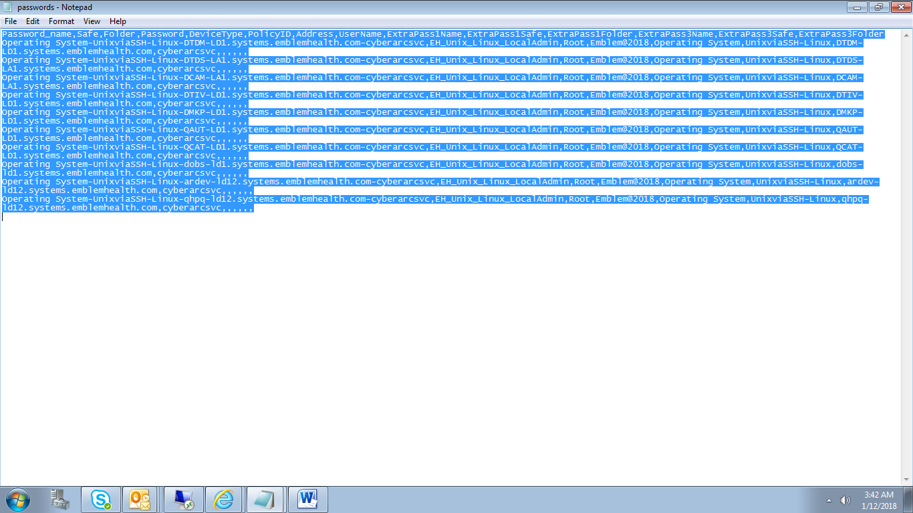

* Copy all the contents.
* Now go back to PVWA Server and run the Command Prompt as Administrator

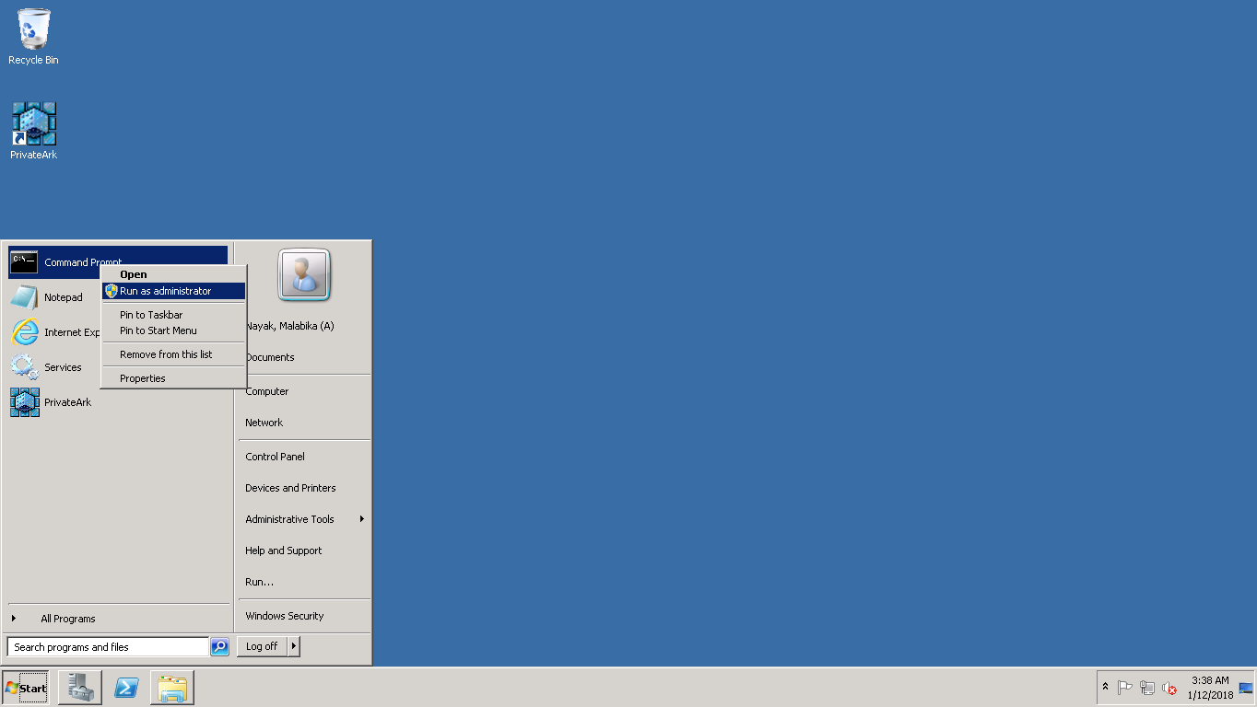

* Give the notepad command and then click on file>open in the notepad that opened up. Browse to C:\Program Files (x86)\CyberArk\Password Upload Utility and select password.csv file and press ok

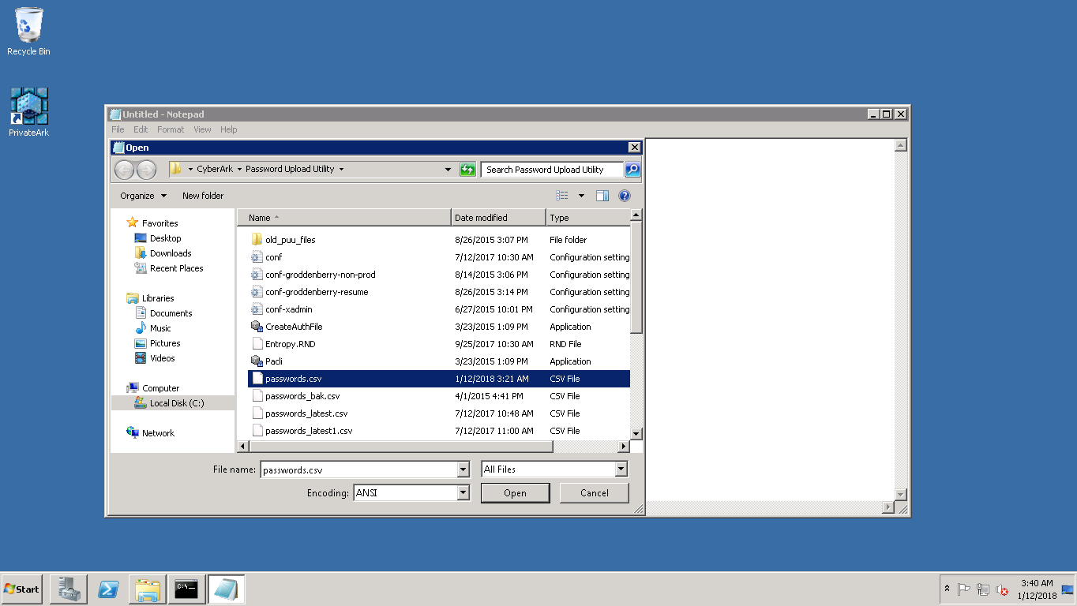

* Paste the contents here that were copied from the password.csv file present in the EH Desktop.

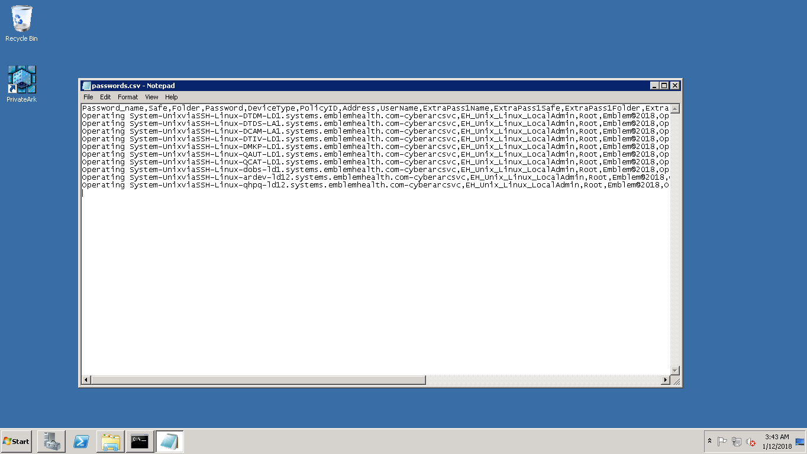

* Go to C:\Program Files (x86)\CyberArk\Password Upload Utility and press shift key and right mouse click simultaneously. Select “Open Command Window here” option and it will open a CMD box

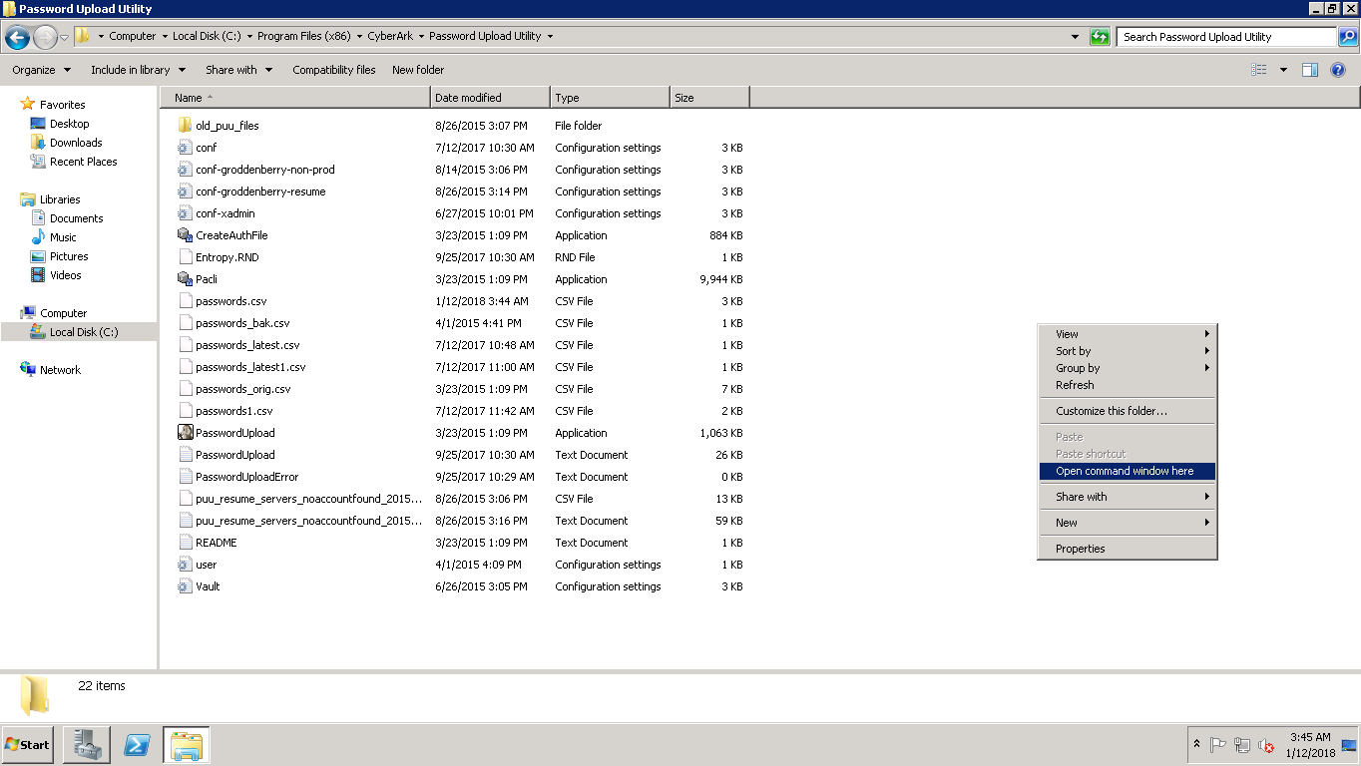

* Run the command “passwordupload.exe conf.ini” and press Enter

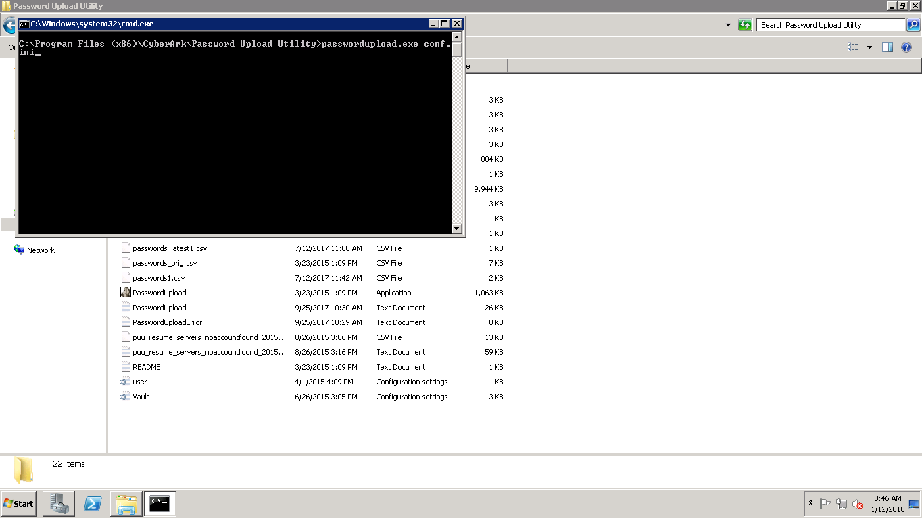

* After this, the accounts will get on boarded on vault.

